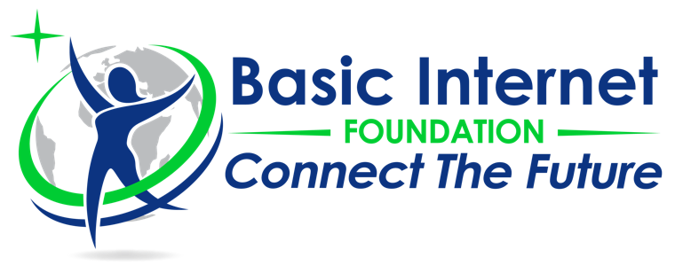

Franchise Agreement (FA) on
«Connect The Future»

Between
The Basic Internet Foundation («BasicInternet») existing under the Norwegian laws with principal office at Kjeller, Oslo
and
…………………. («Franchisee») existing under the …….. laws with principal office at ……………

Whereas the BasicInternet hereby signs a franchise agreement with the Franchisee described as follows:

According to the chosen area of the Franchisee, which is a specified commercial area, without any injustice to any proposal by BasicInternet considered best for the Franchisee’s interest.
Therefore, for and in consideration of the foregoing premises, the parties have agreed to strictly comply with the following terms and conditions:
- BasicInternet hereby honours the Franchise Rights to the Franchisee organising on the signing thereof.
- Franchise fee – The Franchise fee will be $199 for the establishment of the collaboration. The Franchise fee is NON-REFUNDABLE.
- Operation fee – The Franchisee will pay a monthly fee of $2 per InfoSpot.
- Duration – This agreement will be effectual for a period of …. years. Unless terminated through written notice not later than 30 days prior to termination, the agreement will be extended yearly.
- Individuality of franchise site – BasicInternet will not set-up another Franchisee within the same geographic area.
- Provisions – The Franchisee will get an exemption of monthly fee for …. months

About the Partners
The Basic Internet Foundation is a Norwegian Foundation, registered at Gunnar Randers vei 19, 2007 Kjeller, Norway under org. number: 915196489. Basic Internet has the vision to improve the life of every human through free access to information on the Internet. Our solution is two-fold; First, we reach out to areas where there is no Internet. Second, we provide Internet Lite, the freemium model for access.
Our distributed architecture opens for a quick deployment of a cost-effective Internet distribution worldwide, allowing for a reception of a 3G/4G network even in areas with no connectivity. We improve the uptake of internet connectivity by providing local content together with partners, such as health, educational, agricultural and other non-profit information free of charge. The education and health packages, as well as the free access to information on the Internet, empower people’s ability to see the value in the Internet and use the internet effectively. In addition, we improve the economic uplift as non-profitable content such as health and education are provided for free. Through Internet connectivity we prepare for business around the information spots and provide start-ups with the capability to deploy their services.
The costs of the infrastructure itself is as cheap as a mobile phone, about 300 USD. For a CAPEX of about USD 1100 we enable Internet access for everyone in the society. While Internet links are expensive, our information spot solution has OPEX of typically USD 15-20 per month. The business model for freemium access to the Internet is sustainable, though needs a collaboration of stakeholders.
About the Franchisee
………

The partners mutually agree to contribute to resilient communities through digital inclusion in the area of operation. The partners will foster approaches contributing to the free access to information on e.g. education, health, agriculture, entrepreneurship, financial inclusion and digital literacy.
This franchise agreement will start from ………

…………………………………….. ……………………………………………
Prof. Dr. Josef Noll, Secretary General Name:
Basic Internet Foundation Org
m: +47 9083 8066 m:
e: partner@basicinternet.org e:

